**Evolution of Networking**

**Need of a Network:** An “network” additionally enables associated PCs to share documents and information and also equipment assets, i.e., scanners, plotters, projectors and storage devices, making it simpler to gather and administer data, and enabling clients to work together.

The system was simply not advanced in one day; rather took a long time to be an all the more incredible, productive and dependable system. Advancement of systems administration began path back in 1969’s by the improvement of first system called ARPANET, which prompted the improvement of web. At that point after constantly everyday upgradation occur in the system innovation. The system has gone through a few phases which are described below:

**ARPANET (Advanced Research Agency Network):**  
ARPANET was the network that became the basis for the Internet. It was the first network that came into existence in 1969, which was designed and named by the Advanced Research Projects Agency (ARPA) and US Department of Defence (DoD). It was where a bunch of PCs were associated at various colleges and US DoD for sharing of information and messages and playing long separation diversions and associating with individuals to share their perspectives.

**NSFNET (National Science Federation Network):**  
In mid 80’s another federal agency, NSFNET (National Science Federation Network) created a new network which was more capable than ARPANET and became the first backbone infrastructure for the commercial public Internet. Its main aim was to use network only for academic research and not for any kind of private business activity. Later, many privately owned businesses with their very own private systems joined with ARPANET and NSFNET to make more capable and wide network, the Internet.

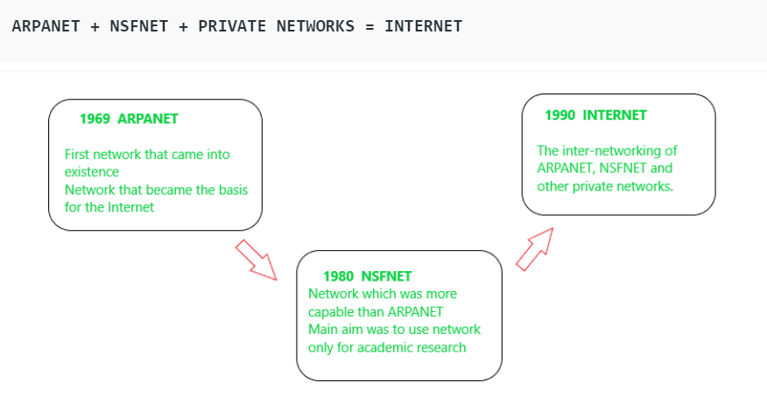

**Internet:**

In the Internet, which is a network of networks, came into existence. The internet has evolved from ARPANET. The internet is a globally connected network system that utilizes TCP/IP to transmit information. It allows computers of different types to exchange information and is known as internet. The Internet is the financially communications method on the planet, in which the following services are instantly available:

* Email
* Web-enabled audio/video conferencing services
* Online movies and gaming
* Data transfer/file-sharing, often through File Transfer Protocol (FTP)
* Instant messaging
* Internet forums
* Social networking
* Online shopping
* Financial services

**Interspace:**

Interspace is a software that allows multiple users in a client-server environment to communicate with each other to send and receive data of various types such as data files, video, audio and textual data. Interspace gives the most exceptional type form of communication available on the Internet today.